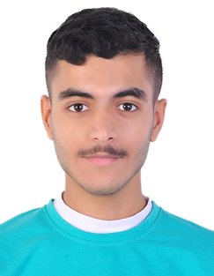 **Hasan Mohamed Baqer**

# 📱 **+973 36449556 |** [**ihassan3644@gmail.com**](mailto:ihassan3644@gmail.com) **|** [C.V. on GitHub](https://github.com/Hassan-1412/work-cv/blob/main/Hasan%20Mohamed%20Baqer.pdf)

Skills:

* Arabic: Native Language
* English: basic communication skills
* Photography

Education:

* **College of Business Administration – University of Bahrain**  
  Associate Diploma in Business Administration (Expected 2025)
* **Al-Tawoon Secondary School for Boys**  
  High School Certificate, 2022

Work Experience:

* Mahd_alazhar_kg – 2020/2021
  + Contributed to logistical planning and event photography for a kindergarten event.

**Achievements and Activities:**

* Traveled alone to different places, showing adaptability and independence.
* Attended courses at the British Council, enhancing English language proficiency.
* Delivered a presentation on **"How to Enhance Self-Confidence"** in a workshop conducted by Mr. Mahmood Hamdan, showcasing communication and public speaking skills.